Order Of Lenten Service

Opening Hymn: TLH 159

Reading: Lent VII

The History of the Passion of our Lord

Sermon Hymn: TLH 656

Sermon Text: Mark 13:28-31

Near—At The Doors

Confession of Sins: O almighty God, merciful Father, I, a poor miserable sinner, confess unto Thee all my sins and iniquities, with which I have ever offended Thee and justly deserved Thy temporal and eternal punishment. But I am heartily sorry for them and sincerely repent of them, and I pray Thee of Thy boundless mercy and for the sake of the holy, innocent, bitter sufferings and death of Thy beloved Son, Jesus Christ, to be gracious and merciful to me, a poor, sinful being.

Holy Communion

The Lord's Prayer

The Blessing

Closing Hymn: TLH 174

* * * * * * * * * * * *

Koinonia Hour

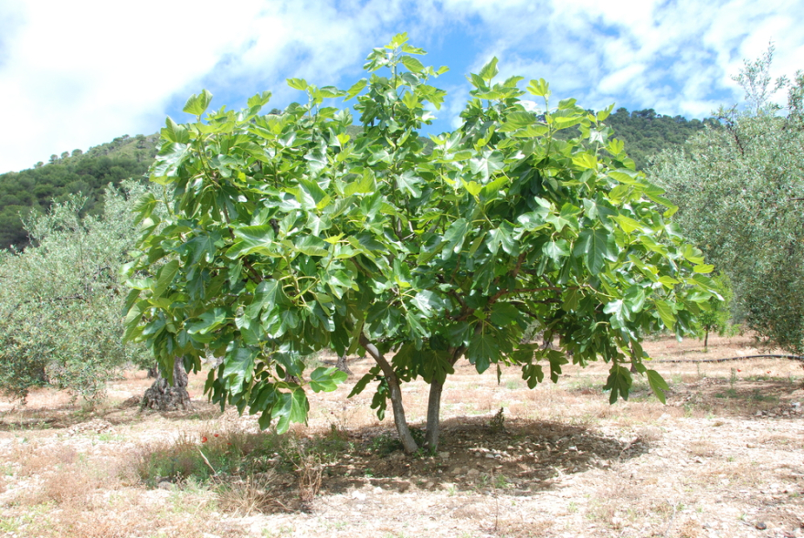

The Fig Tree

Water
Of
Life

5 April 2020

W A T E R O F L I F E

Independent Christian Church—Conservative Lutheran Doctrine

Worship Service: 9:30 a.m. Bible Study: 10:45 a.m.

Larry Cooper, Pastor E-Mail address:
111 N. Ridge Road lcooper@wateroflife.cc
Coon Valley, WI 54623 Web Site:
www.wateroflife.cc

* * * * * * * * * * * * * * * * * * * * * * * * * * *

Sermon Text: Mark 13:28-31

Near—At The Doors

* * * * * * * * * * * * * * * * * * * * * * * * * * *

Mark 13:28 Now learn a parable of the fig tree; When her branch is yet tender, and putteth forth leaves, ye know that summer is near:
:29 So ye in like manner, when ye shall see these things come to pass, know that it is nigh, even at the doors.
:30 Verily I say unto you, that this generation shall not pass, till all these things be done.
:31 Heaven and earth shall pass away: but my words shall not pass away.



